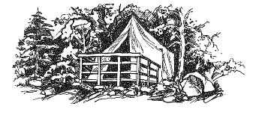
Friends of San Jose Family Camp
Annual Membership Signup / Renewal Form

Name ___________________________________________________
Address _________________________________________________
City _________________________________________ State ______ Zip ____________
Phone number _______________________ Email ________________________________________
Preferred method of contact : Phone ☐ Email ☐
Members in your family – Please indicate age group and gender
Adult (18+) , Teen (13-17) , Pre-teen (10-12) , U10 (under 10) , and Little Nipper (3 and under)
Name ______________________________ Age Group _______________ Gender ______________
Name ______________________________ Age Group _______________ Gender ______________
Name ______________________________ Age Group _______________ Gender ______________
Name ______________________________ Age Group _______________ Gender ______________
Name ______________________________ Age Group _______________ Gender ______________
Name ______________________________ Age Group _______________ Gender ______________
Can you assist with camp improvement projects (workparties) or do you wish to volunteer in any way? Let us know any special skills you have or how you can help as a Friend:
________________________________________________________________________________________________________________________________________________________________________
Are you new to Friends? If so, how did you hear about us? ________________________________________________________________________________________________________________________________________________________________________
Membership type - NEW ☐ RENEWAL ☐ Membership rates – Family ($40) / Individual ($20)
Mail To
Friends of San Jose Family Camp Membership dues $ ____________
PO Box 8237 Monetary Donation $ ____________
San Jose, CA 95155 Total enclosed $ ____________
Email To
membership@friendsofsanjosefamilycamp.org
Forms may be sent to the above address along with payment. Use the QR code for online payments via Paypal. Please visit our website for more information-
www.friendsofsanjosefamilycamp.org/membership
Thank you Friend! We appreciate your support to help preserve and improve the experience at Family Camp at Yosemite.

